SEOWEA Pretreatment & Industrial Workshop, Thursday, Feb 20, 2020
(4.0 Contact Hours)

Come join us for the SEOWEA Pretreatment & Industrial Workshop on Thursday Feb 20, 2020. Lunch will be provided.

The Village of Commercial Point is hosting this event at:
Village of Commercial Point WWTP at 3720 State Rt 762, Lockbourne, OH 43137.

Registration:
Online Registration
SEOWEA Pretreatment & Industrial Workshop Please register on-line by 4 p.m. on Feb 14th, 2020.
Members: $30 Non-members: $35
First-time attendees: No Cost

Registration at the Event
Members: $35 Non-members: $45

P.O. forms can be sent to the attention of Josh Holton at:
Southeast Section OWEA, PO Box 163093, Columbus, Ohio 43216-3093. Josh can be contacted at: Phone: 740-928-0823 jholton@swlcws.com. If you unable to attend, please honor your reservation with a check

SEOWEA Presentation Schedule

9:00-9:30 a.m.: Registration Village of Commercial Point WWTP

9:30 am – 11:00 am: Tour of Commercial Point WWTP
(1.0 Contact hr.)
John Thompson-Village of Commercial Point

11:30am – 12:30 pm: Lunch/Business Meeting
Cooks Creek-
16405 US-23, South Bloomfield, OH 43103

12:30 am – 1:30 pm: Commercial Point Master Planning and Digestion Improvements
(1.0 contact hr.)
Joe Cook- Stantec

1:30pm – 2:30 pm: What are you Looking at?
- contact hr.)
Jeff Bertacchi- City of Columbus

2:30pm-3:30 pm: Improving Wastewater Compliance Rate through 5y Analysis
(1.0 contact hr.)
Sam Frazzini- Aqua Ohio

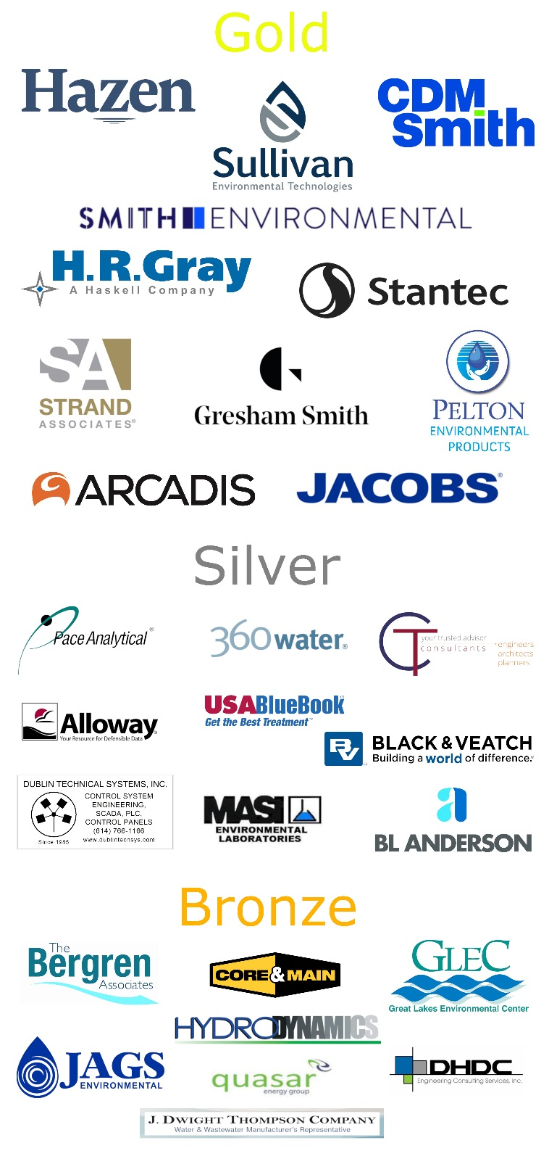
SEOWEA 2019-2020 Patron Program

