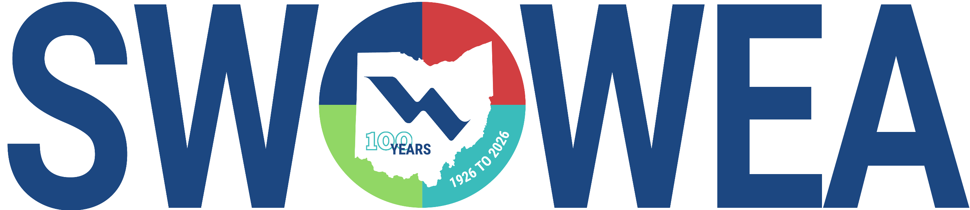

MAY SECTION MEETING
Thursday, May 21, 2026

City of Urbana Water Reclamation Facility
1263 Muzzy Road
Urbana, OH 43078

TOUR and PRESENTATIONS

The SWOWEA 2026 May Section meeting will be held at the Urbana, OH.
The AM section will be a tour of the Water Reclamation Facility and their Septage Receiving Facility.
The PM section will include technical presentations focused on Urbana’s operations and their plant.

CONTACT HOURS

Between 3.5-4 Contact Hours Available.

Food

Donuts, Coffee and Lunch will be provided

Registration

Registration link will be sent soon.
$0 Speakers
$5 Students w/ valid ID
$35 early registration member
$45 early registration non-member
$40 late registration member
$50 late registration non-member

Questions? Please contact Joseph Kamalesh at joseph.kamalesh@stantec.com or 513-842-8219

