SWOWEA Section Meeting
Thursday, September 18, 2025
Host: Little Miami Wastewater Treatment Plant (LMWWTP)
Tour:
9:00- 11:30am Little Miami Wastewater Treatment Plant (LMWWTP)
225 Wilmer Ave.
Cincinnati, OH 45226
OWEA-#####-XX 1.00 hr

Registration:
11:30-12:00 MSD Administration Building
1081 Woodrow St.
Cincinnati, OH 45204
Lunch: 12:00 MSD Administration Building
Boxed Lunches
Assorted Ham, Turkey, Roast Beef
Business Meeting:
12:30 pm Welcome & Business Meeting
Chris Zdinak, SWOWEA President
Technical Sessions:
1:00-1:45 Biological Activated Filtration Piloting at the Little Miami WWTP
Nick Jones, Metropolitan Sewer District of Greater Cincinnati
OWEA-######-OM 0.75 hrs

1:45-2:30 Wastewater Treatment Plant Upgrades for Small Developments
Kathryn Gilbert, Warren County Water & Sewer; Michael Orbash, Strand Associates, Inc.
OEPA-######-OM 0.75 hrs

2:30-2:45 Break & Door Prizes

2:45-3:45 Water Reuse and Advanced Water Treatment Pilot
Alyssa Mayer ; Natalie Thompson, Hazen and Sawyer
OEPA-######-OM 1.00 hr

3:45 Closing Statement
Pre-register by September 13, 2025 To register and make credit card payments visit www.ohiowea.org.
Pre-registration: $45- member; $55- non-member; $5 student ID.
Day of event $55- member; $65- non-member.
Registration is free with a paid OWEA/WEF new
membership application.
Payment Contact: Adam Athmer SWOWEA
Treasurer at adam.athmer@strand.com or (513)
861 5600.
Event Contact: Joseph Kamalesh SWOWEA VP
at Joseph.Kamalesh@stantec.com or (513) 842 8219.
Make Checks Payable to:
Adam Athmer SWOWEA Treasurer
615 Elsinore Place, Suite 320
Cincinnati, OH 45202

Please honor your reservation with payment if unable to attend.

Directions to LMWWTP:
From I-71 South, Exit 9 – Red Bank Rd
Follow I-71 S to Red Bank Expressway, Red Bank Rd, Wooster Rd and Wilmer Ave.
Take Exit 9 for Red Bank Rd. towards Fairfax. Continue onto Red Bank Expressway for 1.1 miles. Turn right onto Wooster Pike for approximately 2.2 miles. Turn right onto Beechmont Circle for approximately 1.5 miles. Turn right onto Wilmer Ave. for approximately .40 miles. Turn right for 1.4 miles.
Turn left for approximately 500 feet. Destination will be on the left

From I-75 North
Take I-75 North until you reach exit #7 toward OH-562 / Norwood / I-71 (Norwood Lateral Expressway) take this exit for approximately 3.1 miles. Take the exit toward Cincinnati onto I-71 South for approximately 1.7 miles. Take exit #5 toward Dana Ave for approximately 0.3 miles. Turn left onto Dana Ave for 0.5 miles. Turn right onto Madison Rd. for approximately 0.5 miles. Keep left onto Torrence Pkwy for approximately 0.6 miles. Turn left onto Columbia Pkwy. (US-50) for 1.7 miles. Turn right onto Stanley Ave. toward Lunken Airport / Coney Island for 0.2 miles. Turn left onto Kellogg Ave (US-52) for 0.9 miles. Turn left onto Wilmer Ave. toward Cincinnati Municipal Lunken Airport for 262 feet.

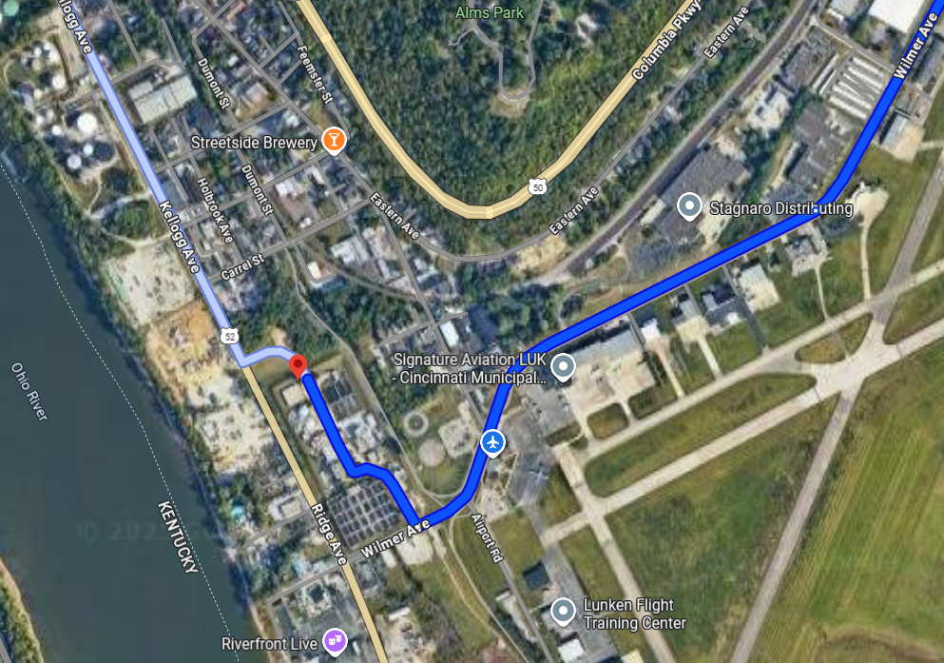

MSD Administration Building from (from LMWWTP):

