

**SEOWEA 2024 Industrial Pretreatment Workshop**

**Thursday October 24th, 2024 (submitted for 4.25 Contact Hours)**

**Primary Workshop location for contact hour forms:**

Coshocton County Commissioners Community Room

637 Chestnut Street, Coshocton, Ohio 43812

**Registration:**

**Online Registration Required**

**SEOWEA 2024 Industrial Pretreatment Workshop**

Please register on-line by 5 p.m. Thursday October 17, 2024.

Members: $45 Non-members: $60

Host/Presenter: No Cost

**P.O. forms can be sent to the attention of William Randles:**

Southeast Section OWEA, PO Box 163093, Columbus, Ohio 43216-3093. William (a.k.a. Tucker) can be contacted at: Phone: 740-801-8436. [William.Randles@coz.org](mailto:William.Randles@coz.org). If you unable to attend, please honor your reservation with a check.

**SEOWEA 2024 Industrial Pretreatment Workshop Schedule – Thursday, October 24th, 2024**

8:15 am – 8:30 am: **Welcome/Greeting**

City of Coshocton WWTP - 2742 Co Rd 271, Coshocton OH 43812

Please use the parking lot at Riverfront Park across the Street north of the WWTP.

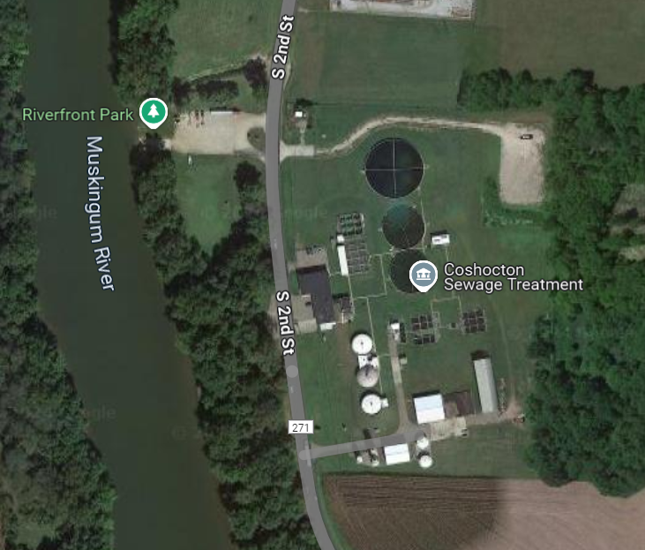

8:30 am – 9:30 am: **City of Coshocton WWTP Tour**

(submitted for 1.0 Contact Hour)

9:30 am – 9:45 am:

**Travel to Mcwane Ductile** 2266 South Sixth Street, Coshocton, OH.

Preferred parking where the red line is shown along Linn Street. Overflow parking will be in yellow colored area. Blue dot is entry.

9:45 am - 10:45 am:  **Tour of McWane Ductile Ohio**

(submitted for 1.0 Contact Hour)

**Required PPE- Closed toed shoes (preferably safety boots), hard hat, safety glasses, and hearing protection. (Ear plugs will be made available)**

10:45 am – 11:00 am:

**Travel to Coshocton County Commissioners Community Room**

637 Chestnut Street, Coshocton, Ohio 43812.Parking is permitted in the lot on 7th and Chestnut Street as well as the First Baptist Church lot on Chestnut St., 646 Chestnut St. and the Municipal Parking lot on Chestnut Street. (see 2nd page of flyer)

11:00 am – 11:45 am:

Technical Presentation: **Creating an EPA Compliant Fats, Oils, &**

**Grease Program**

Presenter: Samuel Mcleod, BMP Compliance Group

(submitted for 0.75 Contact Hour)

11:45 am – 12:45 pm: **Lunch/Networking/Section Updates**

12:45 pm – 1:30 pm:

Technical Presentation: **The Changing Challenges of Industrial**

**Pretreatment**

Presenters: Elizabeth Toot-Levy, Geosyntec Consulting

Jason Westfall, City of Columbus

(submitted for 0.75 Contact Hour)

1:30 pm – 2:15 pm:

Technical Presentation: **Operating a Streamlined EPA Compliant**

**Industrial Pretreatment Program**

Presenter: Samuel Mcleod, BMP Compliance Group

(submitted for 0.75 Contact Hour)

Parking Options for Community Room Circled Below:

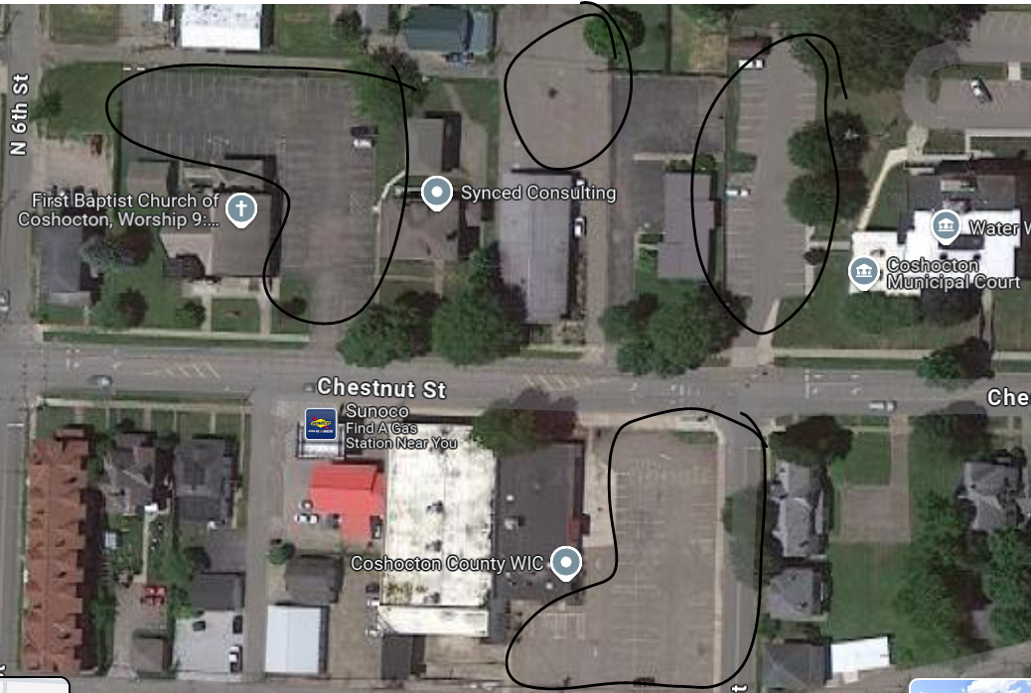

Community Room Entrance along Chestnut St adj/Sunoco (white roof in above photo)



