
SEOWEA 2023 Industrial Pretreatment Workshop
Friday September 15th, 2023 (3.5 Contact Hours)

Primary Workshop location for contact hour forms:
Cardinal Power Plant
306 County Rd 7E, Brilliant OH 43913

Registration:
Online Registration Required – (no walk-ins due to logistics)
SEOWEA 2023 Industrial Pretreatment Workshop
Please register on-line by 4 p.m. Monday September 11, 2023.
Members: $40 Non-members: $50
Host/Presenter: No Cost

P.O. forms can be sent to the attention of Kelli Jamison:
Southeast Section OWEA, PO Box 163093, Columbus, Ohio 43216-3093. Kelli can be contacted at: Phone: 614-601-0051 KJamison@blanderson.com. If you unable to attend, please honor your reservation with a check.

SEOWEA 2023 Industrial Pretreatment Workshop Schedule – Friday September 15th, 2023
8:45 am – 9:00 am: Welcome/Greeting/Coffee/Doughnuts
6000 Guernsey St. Bellaire, OH

Upon exiting 470, take SR 7 south, then first exit will be Guernsey Street, Turn Left on Guernsey Street and facility will be near the end of the road.
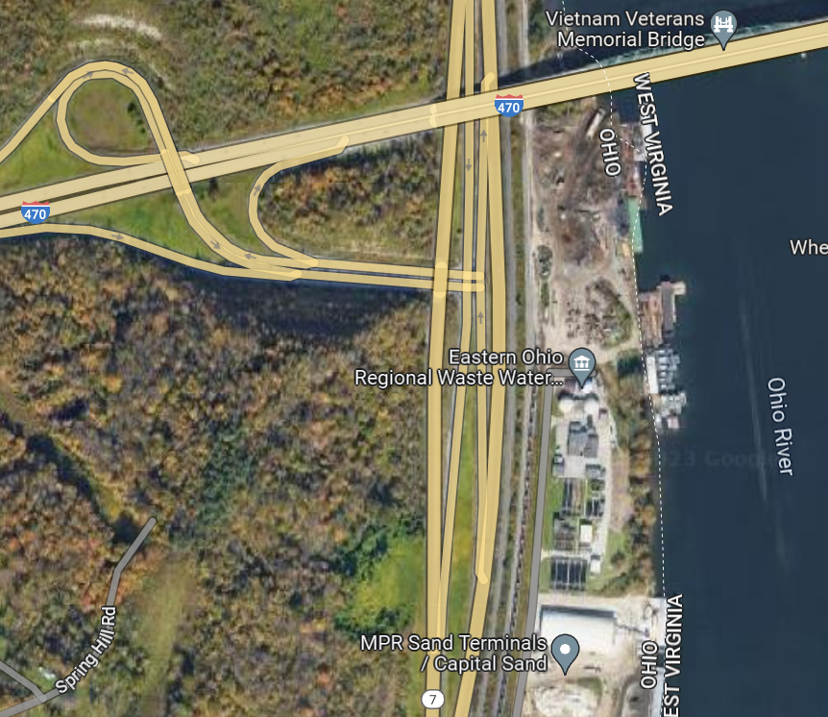

9:00 am – 10:00 am: Tour of EORWA WWTP
6000 Guernsey St. Bellaire, OH
(1.0 Contact Hour)
10:00 am – 10:30 am: Travel Time Allowance to Cardinal
306 County Rd 7E, Brilliant, OH

Take SR7 North to Brilliant follow Cardinal Plant traffic signs– (Parking Details will follow)

10:30 am - 2:00 pm: Tour of Cardinal Power Plant
306 County Rd 7E, Brilliant, OH
(2.5 Contact Hour) – the time slot is expanded to allow for lunch, etc. Required PPE- Please bring safety boots, hard hat, safety glasses, and hearing protection. (Ear plugs will be made available)

Due to capacity of onsite meeting room, the plan is to divide into groups of no larger than 40 rotating into meeting room for presentation/lunch and the various toured areas. Lunch will be provided during presentations.
The tour will include an overview of how the Cardinal Power Plant generates electricity and a focused presentation on environmental controls installed to manage air emissions, wastewater and solid waste. Walking tours will provide attendees the opportunity to see:
- Unit 3 Steam Turbine & Boiler
- Select Catalytic Reduction Systems (SCR’s)
- Flue Gas Desulfurization System (FGD)
- FGD Wastewater Treatment plant
- Cooling Tower
- Bottom Ash Pond System

