
In 1993, the SEOWEA established the Patron Program to support Section activities. If you would like to help support SEOWEA, we encourage you or your business to do so at one of the following levels. If you would like to become a Patron Program Member, or have any questions regarding the Patron Program, do not hesitate to contact a member of the Executive Committee.

Sponsors will be recognized at the Section Social Event and all Section Meetings, on all Section Meeting flyers, and on the Section website at the appropriate sponsorship level.

The sponsor levels are as follows:
Gold: $500.00
Silver: $250.00
Bronze: $100.00

The Patron Program helps support the following Section activities. Many of these activities would not be possible without our sponsors.
- Social Event
- Provide accommodations to the state conference for the YP Paper Award Winner
- Support Young Professional events in the Section
- Maintain low cost for Section Meetings for members
I also want to thank our Patron Program Members from 2025. Your support has been invaluable to our Section Members.

Gold  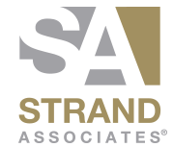       | Silver  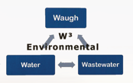     | Bronze    