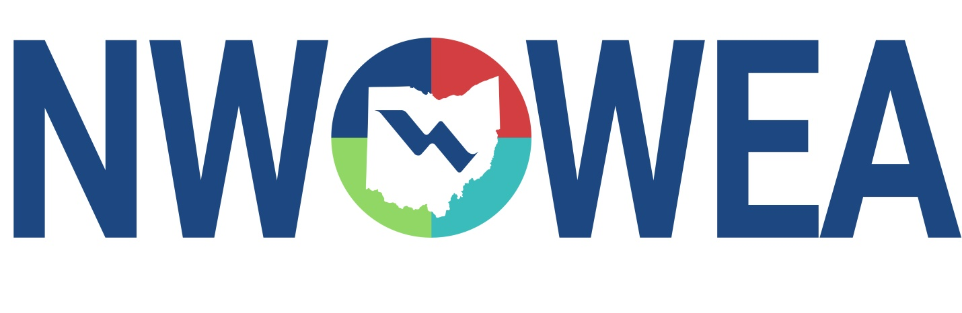

NWOWEA SECTION MEETING
November 6th, 2025
Allen County Sanitary Engineering Dept.
American-Bath Wastewater Treatment Plant
3230 N. Cole St. Lima, OH 45801

8:00 - 8:30 Registration

8:30 - 9:15 Optimizing Pump Station Management – Web-based Monitoring
Brent Nibarger, Grundfos

9:15 – 10:00 Valve Overview: Applications, Maintenance, and Best Practices
Matt Miller, McWane Plant & Industrial

10:00 – 10:15 Break

10:15 - 11:00 Advancements in Wastewater Handling - Solutions to Problematic Pump Stations
Tom Marshall, Crane/Barnes

11:00 - 11:45 Screen Assessment Alternatives for Large Diameter Piping
Drew McKenzie, ADS Environmental

11:45 – 12:30 Lunch

12:30 – 1:30 Northwest Operations Panel – You Want Me To Do What?
Mark Lehnert (Defiance), Bob Ward Jr. (Fremont), & Larry Huber (Lima)

1:30 – 2:00 Awards/Section Update/Door Prizes

2:00 - 3:00 American – Bath Wastewater Treatment Plant Tour

The Northwest Section Would Like To Thank The Following Sustaining Sponsors:

Allied Technical Services INC.
Alloway Environmental Testing, Lima, OH
Arcadis, Toledo, OH
Baker and Associates, Ltd. Carey, OH
BissNuss, Inc., Westlake, OH
Buckeye Pumps Inc., Galion, OH
Dmytryka Jacobs Engineers, Toledo, OH
Fishbeck, Perrysburg, OH
JGM Valve Corp., Commerce, MI
Jones and Henry Engineers, Inc., Toledo, OH
Mosser Construction, Fremont, OH
OH-MAN Enterprises, LLC, Toledo, OH
Peterson Construction, Wapakoneta, OH
Smith Environmental, Columbus, OH
Wessler Engineering, Inc., Bluffton, OH

