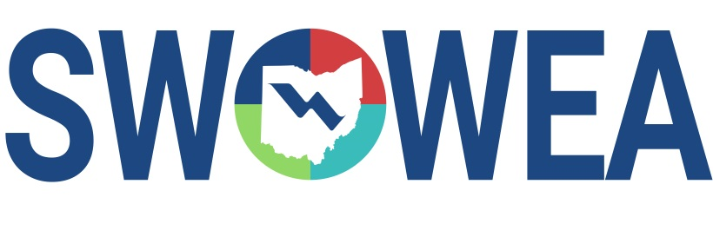
Presents the
SWOWEA November Virtual Seminar
November 5, 2020
hosted by
SWOWEA PLANT OPERATIONS COMMITTEE
PRESENTATIONS
9:00 – 10:00 AM Monitoring Biological Activity in Wastewater
10:00 – 11:00 AM Wastewater Effluent Filtration

CONTACT HOURS
2.0 Contact Hours Available.
Pre-Register Online by 10/31/2020 at www.ohiowea.org
Registrations will only be accepted online, the digital format will not allow for same day registration. Class size may be limited, pre-registration guarantees your seat. Also you will need to register with Go To Meeting as well as OWEA, a link will be sent after your registration has been processed.
Questions? Please contact Bryan McNutt at (937) 478-7723 or bryanm@cityofmiddletown.org

