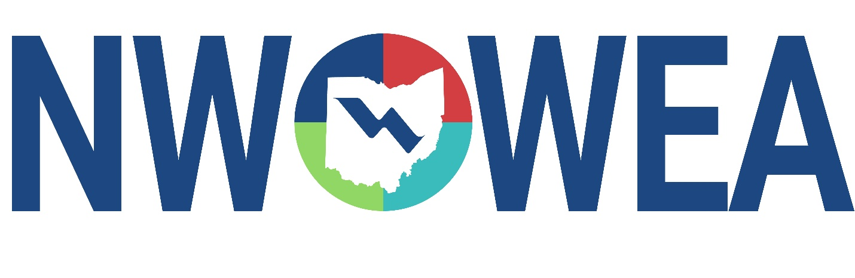
friends & FAMILY DAY
Friday February 27th, 2026

Join NWOWEA as we watch the Toledo Walleye take on the Bloomington Bison at the Huntington Center in Downtown Toledo. We’ll have seats to watch the game as well as access to the Club Level Lounge. Through the support of our sustaining sponsors, NWOWEA is able to offer reduced pricing for members and their families! (Note – Parking is not included – check out https://huntingtoncentertoledo.com/parking/ for options in addition to other street parking in the downtown area).
Event Starts at 6:30 PM Puck Drops at 7:15 PM
Members: $20 Non-Members: $30 Children (12 years and under) $15
- Price includes game ticket and dinner.
Hot dogs/burgers, mac & cheese, potato chips, salad, & pop/water.
- Buffet available until 8 PM in the Club Level Lounge
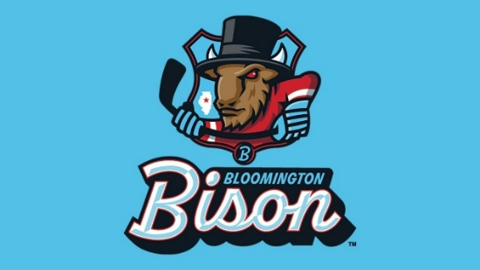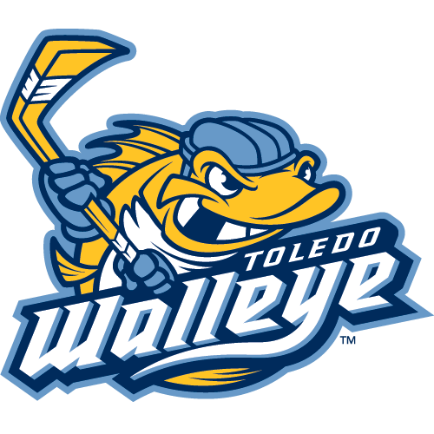

Any Questions? Contact Kevin Connor at kconnor@cityofdefiance.gov
The Northwest Section Would Like To Thank The Following Sustaining Sponsors:

Allied Technical Services INC.
Alloway Environmental Testing, Lima, OH
Arcadis, Toledo, OH
Baker and Associates, Ltd. Carey, OH
BissNuss, Inc., Westlake, OH
Buckeye Pumps Inc., Galion, OH
Dmytryka Jacobs Engineers, Toledo, OH
Fishbeck, Perrysburg, OH
JGM Valve Corp., Commerce, MI
Jones and Henry Engineers, Inc., Toledo, OH
Mosser Construction, Fremont, OH
OH-MAN Enterprises, LLC, Toledo, OH
Peterson Construction, Wapakoneta, OH
Smith Environmental, Columbus, OH
Wessler Engineering, Inc., Bluffton, OH

