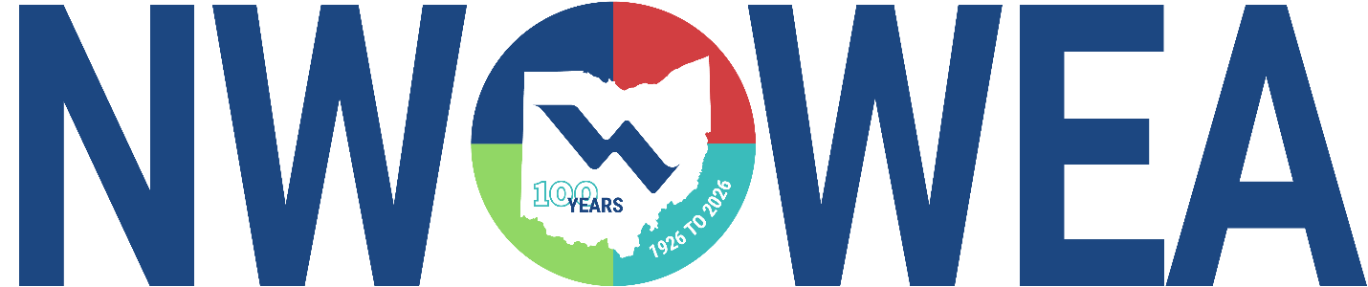

NWOWEA SECTION MEETING
March 18th, 2026

Valleywood Golf Club 13502 Airport Hwy, Swanton, OH 43558
Village of Swanton Water Resource Recovery Facility
300 South St. Swanton, OH 43558

Cost: Members $25 Non-Member $35

8:00-8:30 Registration at Valleywood Golf Club

8:30-9:15 Swanton WRRF: Facility Profile and Recent Improvements
Joe Tillison (Village of Swanton) & Justen Kosmowski (Fishbeck)

9:15– 10:00 Sanitary Sewer Flow Monitoring for I & I Reduction
John Pease (Fishbeck)

10:00 – 10:15 Break

10:15 - 11:00 Optimizing Blower Filtration
Joe Difederico, Endustra

11:00 - 11:45 How to Improve Pump Efficiency
Jon Martin & AJ Mathias, Unconventional Solutions, INC.

11:45 – 12:45 Lunch

12:45– 1:00 Business Meeting/Door Prize

1:15 – 1:30 Travel to Plant

1:30 – 2:15 Swanton Water Resource Recovery Facility Plant Tour
300 South St. Swanton, OH 43558

The Northwest Section Would Like To Thank The Following Sustaining Sponsors:

Alloway Environmental Testing, Lima, OH
Arcadis, Toledo, OH
Baker and Associates, Ltd. Carey, OH
BL Anderson, West Chester, OH
BissNuss, Inc., Westlake, OH
BoJhun Environmental Services, Fostoria, OH
Buckeye Pumps Inc., Galion, OH
Dmytryka Jacobs Engineers, Toledo, OH
D3W Industries, Bowling Green, OH
EnviroScience, Stow, OH
Fishbeck, Perrysburg, OH
Ford Hall, Richmond, KY
HP Thompson, Milford, OH
Jacobs, Columbus, OH
JGM Valve Corp., Commerce, MI
Jones and Henry Engineers, Inc., Toledo, OH
OH-MAN Enterprises, LLC, Toledo, OH
Kokosing Industrial, Toledo, OH
Mosser Construction, Fremont, OH
Pelton Environmental Products, Lewis Center, OH
Peterson Construction, Wapakoneta, OH
R. L. Wurtz Company, Cleveland, OH
Smith Environmental, Columbus, OH
Unconventional Solutions INC., Wixom, MI
Wessler Engineering, Inc., Bluffton, OH
Woodard & Curran, Delphos, OH

