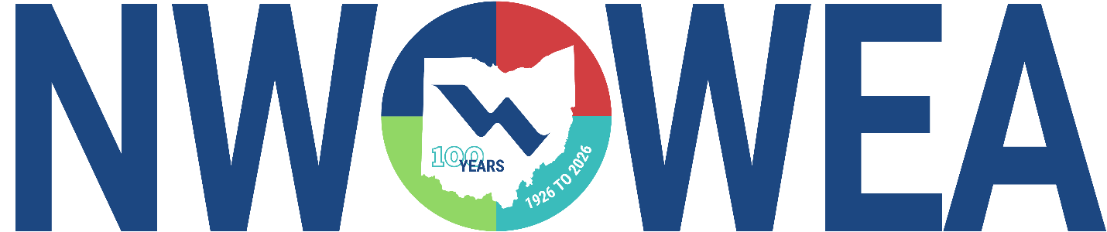

NWOWEA SECTION MEETING
May 13th, 2026

Sandusky Wastewater Treatment Plant
304 Harrison St. Sandusky, OH 44870

Mylander Pavilion at the Jackson St. Pier
223 W. Shoreline Dr., Sandusky, OH 44870

Cost: Members $25 Non-Member $35

8:30-9:30 Sandusky Wastewater Treatment Plant Tour

9:30-10:30 Sandusky Wastewater Treatment Plant Tour

10:30-11:00 Travel to Mylander Pavilion

11:00 – 11:45 High-Rate Treatment for Sandusky: Keeping CSO At (and Out of the) Bay
Mark Loria (Stantec)
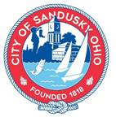
11:45 – 12:30 Lunch

12:30 – 1:15 Zeta-Driven Coagulation
Isabelle Hammer (Stantec)

1:15 - 2:00 Sandusky Digester Improvements
Troy Brehmer (Jones & Henry)

2:00 – 2:15 Break

2:00 - 2:45 Control Panel Fundamentals
Jacob Armstrong, Josh Mullins, & Eric MacMichael (OTC/Buckeye Pumps)

2:45 – 3:00 Business Meeting & Door Prizes
The Northwest Section Would Like To Thank The Following Sustaining Sponsors:

Alloway Environmental Testing, Lima, OH
Arcadis, Toledo, OH
Baker and Associates, Ltd. Carey, OH
BL Anderson, West Chester, OH
BissNuss, Inc., Westlake, OH
BoJhun Environmental Services, Fostoria, OH
Buckeye Pumps Inc., Galion, OH
Dmytryka Jacobs Engineers, Toledo, OH
D3W Industries, Bowling Green, OH
EnviroScience, Stow, OH
Fishbeck, Perrysburg, OH
Ford Hall, Richmond, KY
HP Thompson, Milford, OH
Jacobs, Columbus, OH
JGM Valve Corp., Commerce, MI
Jones and Henry Engineers, Inc., Toledo, OH
OH-MAN Enterprises, LLC, Toledo, OH
Kokosing Industrial, Toledo, OH
Mosser Construction, Fremont, OH
Pelton Environmental Products, Lewis Center, OH
Peterson Construction, Wapakoneta, OH
R. L. Wurtz Company, Cleveland, OH
Smith Environmental, Columbus, OH
Unconventional Solutions INC., Wixom, MI
Wessler Engineering, Inc., Bluffton, OH
Woodard & Curran, Delphos, OH

