WASTEWATER CLASS IV PREPARATION COURSE
Informal course for operators who are interested in or currently pursuing their Class IV license. Discussion led by experienced operators who
have recently completed their Class IV. Discussion leaders will walk through the section requirements and discuss tips and advice.
Thursday–October 23, 2025
City of Findlay Training Center
224 West Crawford Street, Findlay, OH 45840
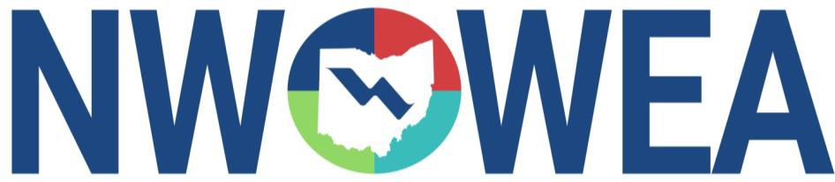
REGISTRATION: 8:30 – 9:00 am Coffee & Donuts
DISCUSSION:  LUNCH:  COST:  BRING: | 9:00 – 10:30 am; 10:45 – 12:00 pm; 12:45-1:15 PM  12:00-12:45 PM Pizza & Soda  $25 OWEA Members/$30 non-members  Questions about the Class IV process
INSTRUCTORS: | Class IV Wastewater Operators
Pre-Registered Attendees Only!
You must be a licensed Ohio Class III operator to attend
Pre-Registration Deadline: October 16, 2025 Pre-Register On Line at www.ohiowea.org
Class size is limited to 30.
This course is approved for 3 Wastewater contact hours.

Questions???
Contact Dave Wilson, 513-907-3793; DWilson@blanderson.com
Or
Seth Rosselit, 419-296-2773; srosselit@findlayohio.gov

