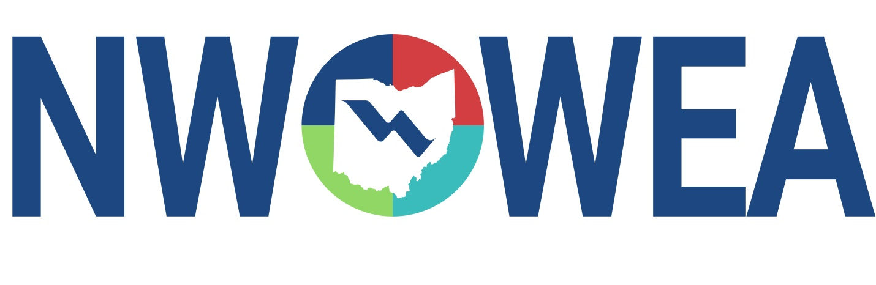

OWEA NW SECTION MEETING/GOLF OUTING
May 26, 2021
Ohio Energy & Advanced Manufacturing Center
1220 S. Main St, Lima, OH 45804

8:15-9:15 Registration

9:15-9:30 Welcome and Introduction

9:30- 10:15 TBD (Alloway Lab Presentation)

10:15- 11:00 Lima’s CSOs. The Good, The Bad, and The Future.
By: Emily Kerber

11:00- 11:15 Break

11:15-12:00 TBD (Lima CSO Basin Construction, Peterson Construction)

12:00 -12:45 Lunch

1:00- 1:45 Alloway Laboratory Tour; Located inside the OEAMC Building

1:00 Golf Outing; Hidden Creek Golf Club, 6245 Sugar Creek Rd. Lima, OH 45801
$32/Person payable to NWOWEA (not to golf course). Portion of proceeds to Water For People/Charitable Giving

The Northwest Section Would Like To Thank The Following Sustaining Sponsors;

Alloway Environmental Testing, Lima, OH
Baker and Associates, Carey, OH
BissNuss, Inc., Westlake, OH
Dmytryka Jacobs Engineers
Jones and Henry Engineers, Inc., Toledo, OH
Mosser Construction, Fremont, OH
Peterson Construction Company
Poggemeyer Design Group, Inc., Bowling Green, OH
Smith Environmental, Columbus, OH
The Bergren Associates, Sylvania, OH
Waterworks Systems and Equipment, Inc., Lakeland, MI
Crown Battery Mfg. Co, Fremont, OH
BL Anderson, West Chester, OH

