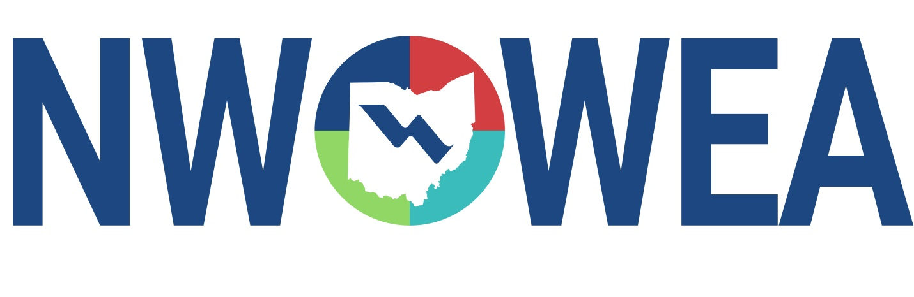

NWOWEA SECTION MEETING

**May 22, 2024**

**Knights of Columbus Hall**

**1242 E. Center St., Marion, OH 43302**

8:00-8:30 **Registration**

8:30-9:15 **Conversion of Water and Wastewater Streams into Beneficial Reuse Potential**

9:15 – 9:30 **Break**

9:30 – 10:15 **Respirometry in WWTP**

10:15 – 10:30 **Break**

10:30 - 11:15 **Long-Term Control Plan Implementation Strategy**

11:15 – 11:45 **Business Meeting**

11:45 – 12:45 **Lunch**

1:00 – 2:00 **Marion Water Pollution Control Plant Tour**

**1810 Marion Agosta Road**

**Marion, OH 43302**

**The Northwest Section Would Like To Thank The Following Sustaining Sponsors:**

**Baker and Associates, Ltd. Carey, OH**

**BissNuss, Inc., Westlake, OH**

**Dmytryka Jacobs Engineers, Toledo, OH**

**Jones and Henry Engineers, Inc., Toledo, OH**

**Mosser Construction, Fremont, OH**

**Smith Environmental, Columbus, OH**

**The Bergren Associates, Sylvania, OH**

**Waterworks Systems and Equipment, Inc., Lakeland, MI**

**Wessler Engineering, Inc., Bluffton, OH**

**Kokosing, Fredericktown, OH**