SWOWEA Section Meeting
Thursday, 19 May 2022
Host: Greene County Sanitary Engineering Department

Tour: Sugarcreek WRRF
2365 State Route 725,
Spring Valley, OH 45370

9:00-11:00am Sugarcreek WRRF Tour:
OWEA-XXXXX-XX 0.75 hrs
Meet at the Administration Building

Registration:
11:30 to 12:00 Greene County Media Room
595 Ledbetter Road
Xenia, OH 45385

Lunch: 12:00 LMR Catering, Buffet Style.
Hickory Smoked Hog & Smoked Turkey Breast, Side salad, Macaroni and Cheese, and Green Beans.

Business Meeting:
12:30 Welcome
Greene County Agency Rep
Business Meeting
David Reinker, SWOWEA President

Technical Sessions:
1:00-1:45 Moving the Needle: Advancing Your Workforce Through Development and Planning
Jason Tincu and Mark Chandler, Greene County Sanitary Engineering Department
OWEA-XXXXXXXXX-OM 0.75 hrs

1:45-2:30 Greene County WRRF Master Plan Recommendations
Mark George, P.E., PMP and Fred Smith, P.E.
OWEA-XXXXXXXXX-OM 0.75 hrs

2:30-2:45 Break & Door Prizes

2:45-3:30 Devastation to Optimization and Everything In-between
Adam Athmer, PE, Strand Associates, Inc.
OWEA-XXXXXXX -OM 0.75 hrs

3:30 Closing Statement

Pre-register by 12 May 2022 www.ohiowea.org. Pre-registration fees are $20 members, $30 non-members, $5 students (w/ID). Walk-ins -$35 members, $50 non-members.
Contact: Ed Smith, SWOWEA Treasurer at esmith@masonoh.org or (513) 229-8570.
Credit card payment is available through www.ohiowea.org only. Meeting is free for new members with paid membership application. Please honor your reservation with payment if unable to attend.

We will be following CDC and state guidelines regarding COVID-19 which may include masks, social distancing, and other safety measures. The latest CDC guidelines for preventing the spread of Covid-19 can be found here: https://www.cdc.gov/coronavirus/2019-ncov/index.html

Directions to Sugarcreek WRRF Tour:
From I-75N, Exit 43 – I-675N
Take exit 7 for Wilmington Pike toward Centerville/Bellbrook.
Turn right onto Wilmington Pike.
Turn left onto OH-725 E/W Franklin St.
Turn right at 2365 OH-725.

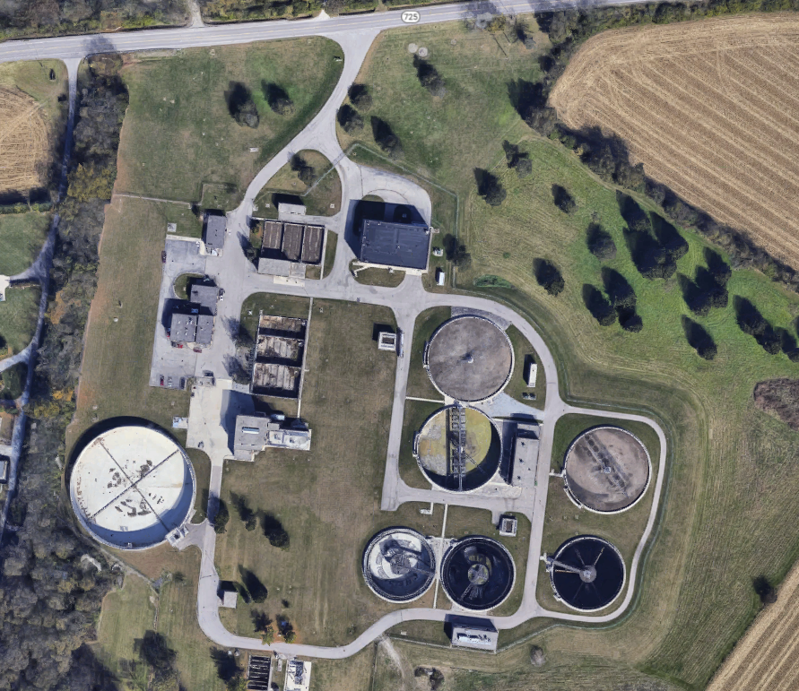

Directions to the Greene County Media Room:
Turn right onto OH-725 E.
Turn left onto Bellbrook Ave
Turn left onto Main St/Old U.S. 42
Turn left onto Old U.S. 42.
Turn left onto US-42 N.
Turn right onto Ledbetter Rd.
Parking lot immediately on your right.

