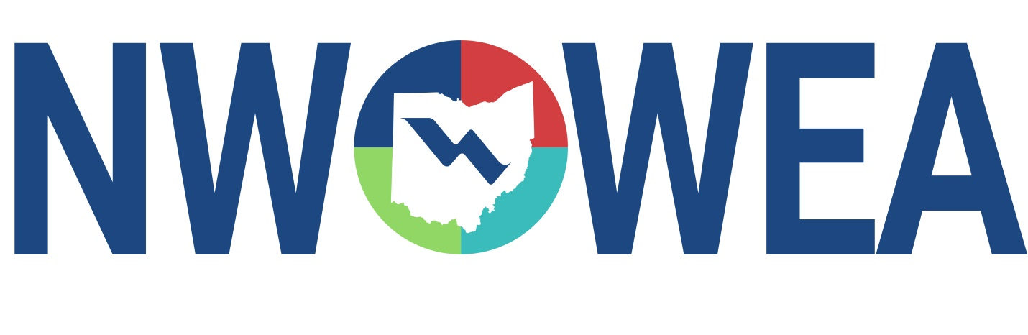

OWEA NW SECTION MEETING
March 24, 2021
Vaughn Industries
1201 E. Findlay St. Carey, OH 43316

8:15-9:15 Registration

9:15-9:30 Welcome and Introduction

9:30 – 10:15 Scum Handling “A Different World”

10:15 – 11:00 Plan Review

11:00 – 11:15 Break

11:15-12:00 Covid -19 Sampling Update

12:00 – 12:45 Lunch

12:45 – 1:00 Business Meeting

1:00 – 1:30 Ugh, Grit!

1:30 – 2:15 Carey WWTP Update

2:30 – 4:30 One-hour plant Tours at Carey Wastewater Treatment Plant, 205 S. Wyandotte Ave. Carey, OH 43316

The Northwest Section Would Like To Thank The Following Sustaining Sponsors;

Alloway Environmental Testing, Lima, OH
Baker and Associates, Carey, OH
BissNuss, Inc., Westlake, OH
Dmytryka Jacobs Engineers
Jones and Henry Engineers, Inc., Toledo, OH
Mosser Construction, Fremont, OH
Peterson Construction Company
Poggemeyer Design Group, Inc., Bowling Green, OH
Smith Environmental, Columbus, OH
The Bergren Associates, Sylvania, OH
Waterworks Systems and Equipment, Inc., Lakeland, MI
Crown Battery Mfg. Co, Fremont, OH

