SWOWEA Section Meeting
Thursday, 24 March 2022
Host: Metropolitan Sewer District of Greater Cincinnati

Tour: Lick Run VCS
Limited Parking available at:
1669 Queen City Ave.
Cincinnati OH 45214

9:00-11:30am Lick Run VCS Tour:
OWEA-XXXXX-XX 2.0 hrs
Meet at the Headwater Area. Wear proper footwear for a 3-mile walking tour. No hardhats or safety vests required. Tours will start between 9-9:15.

Registration:
11:30 to 12:00 The Sanctuary
2110 Saint Michael Street,
Cincinnati, Ohio 45204

Lunch: 12:00 Hammann's Catering, Buffet Style.
Tossed salad, corn bread/rolls,
pulled pork, brisket, BBQ chicken quarters
garlic whipped potatoes, creamy coleslaw, and green beans.

Business Meeting:
12:30 Welcome
MaryLynn Lodor, Deputy Director, MSDGC
Business Meeting
David Reinker, SWOWEA President

Technical Sessions:
1:00-1:45 Miamisburg Eastside Pump Station
Construction and Lessons Learned
Ed Brown, PE, Hazen & Sawyer
OWEA- XXXXX-XX 0.75 hrs

1:45-2:15 Lick Run Greenway
Operations and Maintenance
Leslie Schehl, PE, & Deb Leonard, MSDGC
OWEA- XXXXX-XX 0.50 hrs

2:15-2:45 Break & Door Prizes

2:45-3:30 Lick Run Valley Conveyance System
Construction and Lessons Learned
Mike Ellerbrock, PE, Strand Associates, Inc.
OWEA- XXXXX-XX 0.75 hrs

3:30 Closing Statement

Pre-register by 17 March 2022 www.ohiowea.org. Pre-registration fees are $20 members, $30 non-members, $5 students (w/ID). Walk-ins -$35 members, $50 non-members.
Contact: Ed Smith, SWOWEA Treasurer at esmith@masonoh.org or (513) 229-8570.
Credit card payment is available through www.ohiowea.org only. Meeting is free for new members with paid membership application. Please honor your reservation with payment if unable to attend.

We will be following CDC and state guidelines regarding COVID-19 which may include masks, social distancing, and other safety measures. The latest CDC guidelines for preventing the spread of Covid-19 can be found here: https://www.cdc.gov/coronavirus/2019-ncov/index.html

Directions to Lick Run VCS Tour:
From I-75, Exit 2B – Western Hills Viaduct
Head west on Western Hills Viaduct toward Harrison Ave.
Take the 1st right onto Harrison Ave.
Turn left onto Queen City Avenue.
Parking along Old Queen City between Lick Run Way and Forebay.

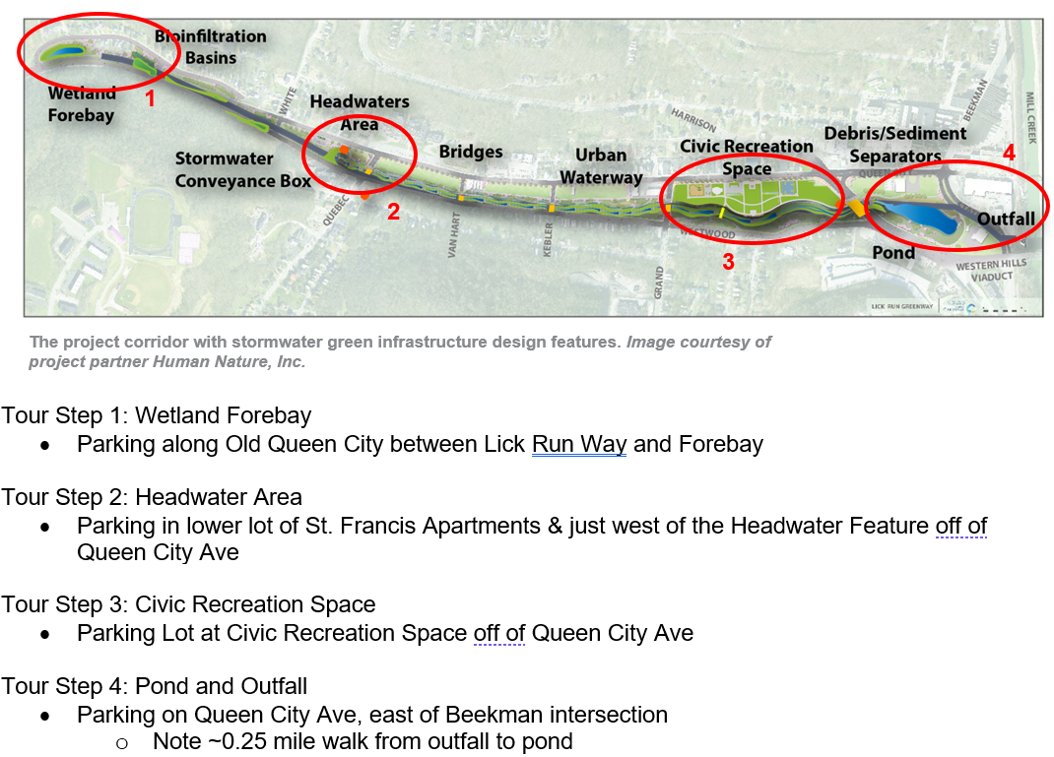

Directions to The Sanctuary:
Head East on Westwood Ave.
Continue onto Harrison Ave.
Use the lane to take the State Ave. ramp.
Turn Right on to State Ave.
Continue for 1.6 miles.
Turn Left onto St. Michael St.
The Sanctuary will be on your Left.
Free parking is available within side lots adjacent to the Sanctuary located from St. Michael Street and rear parking lot accessed from Storrs Street. Ample free on street parking is available on all adjacent streets as needed.

