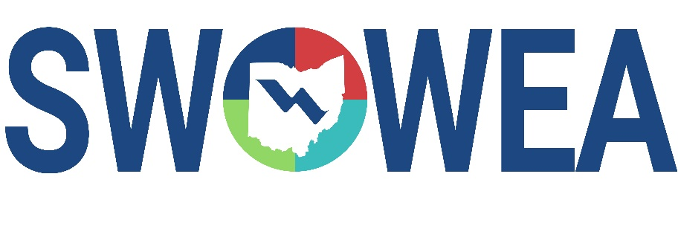
Presents the 36th Annual

Industrial Waste Seminar
&
SWOWEA Section Meeting
Thursday, January 22, 2026

Manor House
7440 Mason Montgomery Road
Mason, Ohio 45040

CONTACT HOURS
Between 5-6 Contact Hours will be available.

EXHIBITORS

The Seminar will include an Exhibitor area displaying various products,
equipment and services related to waste treatment.

SEMINAR REGISTRATION INFORMATION

Early Attendee Registration (no later than 1/9/26) - $80
Late Attendee Registration/Walk In (after 1/9/26)- $90

Early Exhibitor Registration (no later than 1/9/26) - $300
Late Exhibitor Registration (after 1/9/26) - $400

Sponsorship - $150 (Your name and logo will be prominently displayed)

Registrations accepted online through 1/21/26. Walk-ins are welcome the day of event.
Pay at the door by cash or check; make checks payable to “SWOWEA”.

