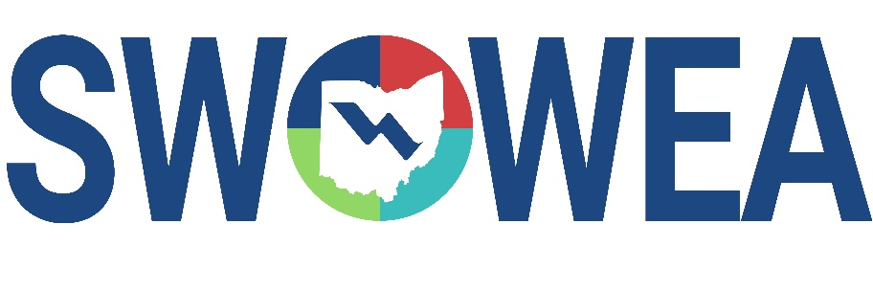
Presents the 32nd Annual

Industrial Waste Seminar
&
SWOWEA Section Meeting
Thursday, January 27, 2022

Manor House
7440 Mason Montgomery Road
Mason, Ohio 45040

CONTACT HOURS
Contact Hours have been approved for 5.25 hours for Technical Sessions.

EXHIBITORS

The Seminar will include an Exhibitor area displaying various products,
equipment and services related to plant operations and maintenance.

SEMINAR REGISTRATION INFORMATION

Early Attendee Registration (no later than 1/14/22) - $75
Late Attendee Registration/Walk In (after 1/14/22)- $85

Early Exhibitor Registration (no later than 1/14/22) - $300
Late Exhibitor Registration (after 1/14/22) - $400

Sponsorship - $150 (Your name and logo will be prominently displaced)

https://www.viethconsulting.com/members/evr/reg_event.php?evid=29083279&orgcode=OWEA

Registrations accepted online through 1/26/22. Walk-ins are welcome the day of event.
Pay at the door by cash or check; make checks payable to “SWOWEA”.

Evening Mixer: Join us at a local brewery (TBD) for Refreshments and Snacks
Just Minutes from Manor House!

AGENDA

7:30 AM – 12:00 PM |  | Registration Lobby
7:30 – 9:00 AM |  | Continental Breakfast Exhibitors Area (Magnolia Room)
Morning – Augusta Room
8:25 – 8:30 AM |  | Opening Remarks – Jeff Frechtling, Co-Chair
8:30 – 9:15 AM |  | OEPA Update  Tyler Bowman, Ohio EPA
 |  | (OEPA-###-## – 0.75 hr)
9:15 – 10:15 AM |  | Wastewater Pretreatment at Rhinegeist Brewery  Janae Chaney, Rhinegeist Brewery  (OEPA-###-## – 1.0 hr)
10:15 – 10:45 AM |  | Morning Break with Refreshments (Exhibitors Area – Magnolia Room)
10:45 – 11:15 AM |  | Wastewater Surveillance – Raw Sewage – Raw Data  Bruce Smith and Dan Murray, USEPA  (OEPA-###-## – 0.5 hr)
11:15 AM – 12:00 PM |  | Lagoon Return Activated Sludge  Ben Shakman, Triplepoint Environmental  (OEPA-###-## – 0.75 hr)
12:00 – 1:00 p.m. |  | Lunch and SWOWEA Section Meeting (Magnolia Room)  Dave Reinker - SWOWEA President
1:00 – 1:15 PM | Karl G. Voelkel Industry Award  TBD
Afternoon – Augusta Room
1:15 – 2:15 PM |  | Empire Packing  Kris Berry and Mike Otter, Empire Packing; Shawn Hollon, City of Mason  (OEPA-###-## – 1.0 hr)
2:15 – 2:45 PM |  | Engineering a Flexible High Performance Industrial Wastewater Treatment Facility – A Case Study of the Hershey Company’s Wastewater Treatment Project  Graig Rosenberger, Veolia Water Technologies.  (OEPA-###-## – 0.5 hr)
2:45 – 3:15 PM |  | Afternoon Break with Refreshments (Exhibit Area – Magnolia Room)

3:15 – 4:00 PM | Industrial Odor Control  Nick Lionas, D3W Industries  (OEPA-###-## – 0.75 hr)
4:00 – 4:05 PM | Closing Remarks – Barb Swafford, Co-Chair
Evening Mixer: Join us at a local brewery (TBD)

