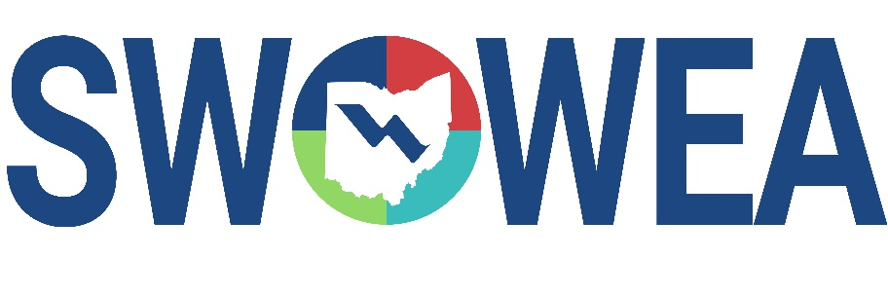
Plant Operations Committee Presents

Plant Operations August Seminar
Thursday, August 19, 2021
8:30am – 12:30pm

Greene County Fairgrounds
120 Fairground Rd.
Xenia, OH 45385

PRESENTATIONS

Topics include: dewatering, process modeling, a plant profile and a round table discussion

CONTACT HOURS

Up to 3.0 Contact Hours Available.

LUNCH

Boxed lunch and ice cream cup will be provided by Young’s Dairy

Registration

Pre-Register Online by 8/12/21 at www.ohiowea.org
Registrations accepted day of event on a “first come, first serve” basis, event
size may be limited, pre-registration guarantees your seat.
Pay online or at the door by cash or check; make checks payable to “SWOWEA”.

$15 member pre-registered (before 8/12/21)
$20 non-member or late registration (after 8/12/21)

Questions? Please contact Bryan McNutt at bryanm@cityofmiddletown.org or (513) 425-7989

