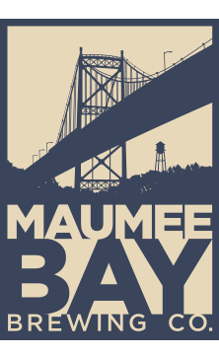
Come join the AWWA & OWEA YP groups for a free brewery tour and happy hour!
When: Thursday, September 29, 2022, at 4:00 PM
Location: Maumee Bay Brewing Company
27 Broadway St.
Toledo, Ohio 43604
1 Contact Hour Available for Water or Wastewater!
Sign up today at:

