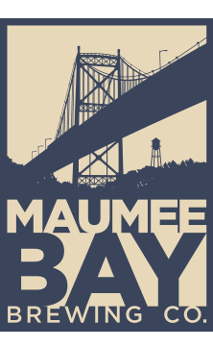
Come join the AWWA & OWEA YP groups for a free brewery tour and Happy Hour!
When: April 2nd, 2020 at 4:00 PM
Location: Maumee Bay Brewing Company
27 Broadway
Toledo, Ohio 43604

Sign up today at ohiowea.org

