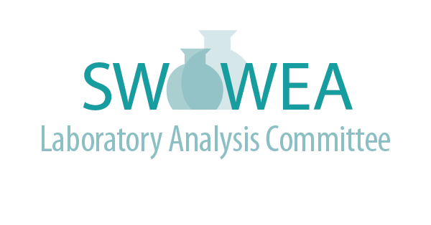


Summer Meeting
July 30th, 2024
Hosted By:
Greene Co. Sanitary Engineering

Agenda
(3.5 Contact Hours Pending)
- 9:00 - 9:30 Registration (Bring your own Lunch)
- 9:30 - 9:45 Welcome and Introductions – Mark Chandler, Director, Greene County
- 9:45 - 10:30 Automatic Samplers 101–Keith Hicks, GRIPP Inc.
- 10:30 - 11:30 Innovations in Sampling – EnviroGo Platform and Drone Sampling – John Hoffman, Alloway
- 11:30 - 1:00 Lunch – On your Own
- 1:00 - 1:45 Water/Wastewater Leak Detection Dogs – Elisa Jones, City of Oxford WWTP
- 1:45 - 2:45 Troubleshooting BOD in the Wastewater Lab – Amy Staley, City of Lima WWTP

Presentations will be at Greene County Social Services Media Room located at 541 Ledbetter Road, Xenia, OH 45385.

Directions to Greene County Social Services Media Room

From Dayton: Take US 35 East to 35 Bypass around Xenia. Take the US 42 North exit. Turn right at the first intersection (Ledbetter Road). Service Center is on the right.

From Cincinnati: Take I 71 North to Exit 28 (SR 48). Merge onto SR 48 North. SR 48 becomes US 42 Bypass North. Turn right at US 42. Follow US 42 through Waynesville to Xenia. After passing under the US 35 overpass, turn right at the first intersection (Ledbetter Road). Service Center is on the right.

From Columbus: Take I 71 west to Exit 52A (US 68). Proceed south on US 68. In Xenia, US 68 becomes Detroit Street. Stay on Detroit Street through Xenia (do not take SR 68). Turn Right on Ledbetter Road. Service Center is on the left.

Registration will be limited. Register online at www.ohiowea.org/ and go to the ‘Events Registration’ tab.

For additional information, contact:

Jim Davis, LAC Co-Chair
Montgomery County Environmental Lab
davisji@mcohio.org
937-496-7795

Lori Kyle, LAC Co-Chair
Greene County Sanitary Engineering
lori.kyle@greenecountyohio.gov

937-562-7151

Committee Members:

Sviatlana Haubner, Cincinnati MSD
Craig Clements, City of Fairfield
Fritz Schroder, City of Dayton
Gregg Mitchell, City of Sidney
Roger Rardain, City of Fairborn


Teresa Shinkle, Greene County



