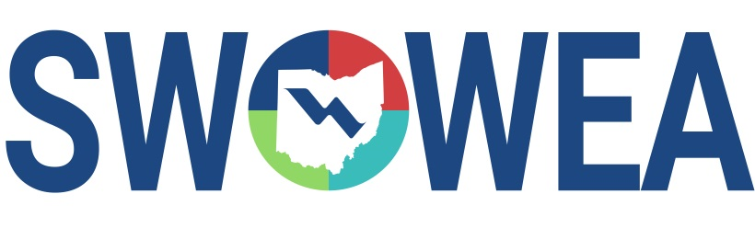

Presents the 22nd Annual:

##### SWOWEA Plant Operations Seminar

**&**

**SWOWEA Section Meeting**

Thursday November 21, 2024

*hosted by*

SWOWEA PLANT OPERATIONS COMMITTEE

CONTACT HOURS

Up to 5.5 Contact Hours anticipated

EXHIBITORS

The Seminar will include an Exhibitor area displaying various products, equipment and services related to plant operations and maintenance.

Pre-Register Online by 11/13/24 at [www.ohiowea.org](http://www.ohiowea.org)

Early Registration (by 11/13/24)- $85.00 Member Registration (by 11/13/24) - $75.00  
Late Registration (after 11/13/24) - $100.00

Registrations accepted day of event on a “first come, first serve” basis, event size may be limited, pre-registration guarantees your seat.  
Pay online or at the door by cash or check; make checks payable to “SWOWEA”.

Questions? Please contact Bryan McNutt at bryanm@cityofmiddletown.org or (937) 478-7723