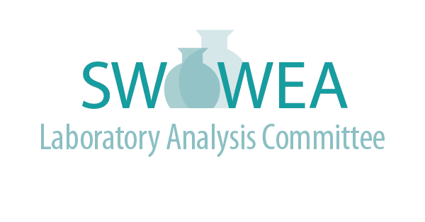

Summer Meeting
July 19th, 2022
Hosted by Metropolitan Sewer District of Greater Cincinnati Laboratory

Agenda
(3 Contact Hours Pending)
- 11:00 – 11:30 Registration (Tours Begin as people arrive)
- 11:30 – 12:30 Laboratory Tour (Groups will start as people arrive)
- 12:30 - 12:45 Welcome, Update, and Introductions
- 12:45 – 1:30 Analysis of Per- and Polyfluoroalkyl Substances - Niranjan Selar, Greater Cincinnati Waterworks
- 1:30 – 2:00 Laboratory Housekeeping and Safety Review, Ralph Rabish, MSD
- 2:00 – 2:45 Going Paperless, Robin Shafer, MSD

Directions to the Metropolitan Sewer District of Greater Cincinnati Laboratory, 1081 Woodrow Street, Cincinnati, Ohio, 45204 (Contact: Sviatlana Haubner, 513-557-7035 office, 513-404-1689)

From I-75 Southbound: Take exit 1F – Freeman Avenue. Turn right at the end of the exit ramp onto Gest Street. Proceed west on Gest Street for approximately 0.7 miles. Turn right onto Woodrow Street.
The Lab is on the left at the end of the street.

From I-75 Northbound: Take exit 1D to merge onto 6th St Via/US-50 toward River Rd. Continue to follow US-50 for 1.7 miles. Turn right at Evans St. Go to the end of Evans St and turn left (don’t enter plant gates). This will lead you to the front of the building.

Registration will be limited. Register online at www.ohiowea.org/, go to the ‘Events’ tab and select the SWOWEA LAC meeting.

For additional information, contact:

Jim Davis, LAC Co-Chair
Montgomery County Environmental Lab
davisji@mcohio.org
937-781-3016

Lori Kyle, LAC Co-Chair
Greene County Sanitary Engineering
lori.kyle@greenecountyohio.gov
937-562-7150

Committee Members:

Sviatlana Haubner, Cincinnati MSD
Craig Clements, City of Fairfield
Fritz Schroder, City of Dayton
Gregg Mitchell, City of Sidney
Roger Rardain, City of Fairborn
Teresa Shinkle, Greene County

