SWOWEA BOGO Section Meeting
Wednesday, September 20, 2017
Receive two plant tours for the price of one!!
Muddy Creek WWTP & Indian Creek WWTP

Host: Metropolitan Sewer District of Greater Cincinnati

Tours: Muddy Creek WWTP
6125 River Rd
Cincinnati, OH 45233
Coffee and Donuts (Sponsored By Dugan & Meyers)

Indian Creek WWTP
1 Harbor Drive
North Bend, OH 45042
Coffee and Donuts (Sponsored By Jacobs Engineering Group Inc)

8:30 Plant Tours Begin
Meet at Administration Buildings
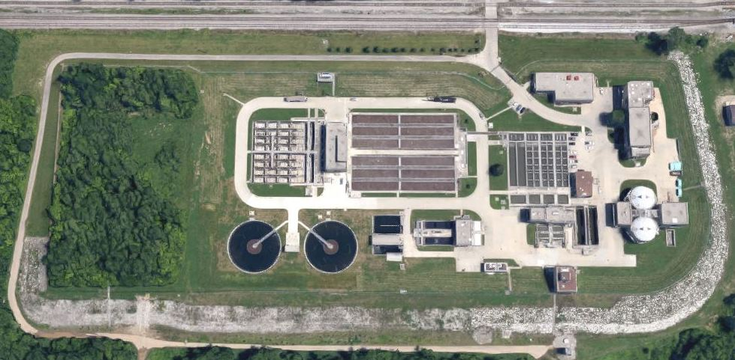
MUDDY CREEK WWTP
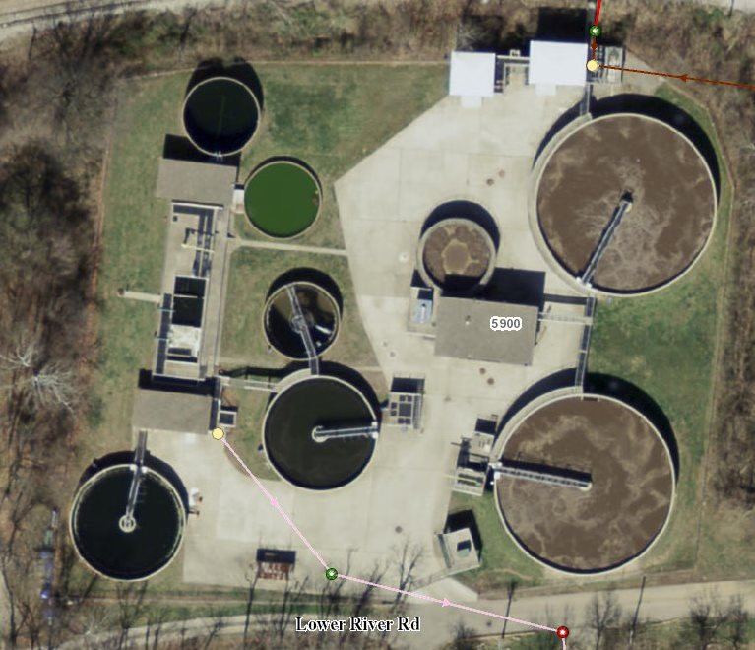INDIAN CREEK WWTP

Registration: Glen Carder Lodge
11:00 to 12:00 5125 Foley Road
Cincinnati, Ohio 45238
_____________________________________________
Lunch: 12:00 Catering to be provided by:
Menu to follow soon.

Business Meeting:
12:30-1:00 Welcome
Metropolitan Sewer District of Greater Cincinnati
Steven Reese, SWOWEA President

Technical Sessions:
Sessions will begin at 1:00 PM and last until 4:00 PM.
OEPA contact hours will be applied for each of the sessions and plant tours.
There will be one afternoon break for dessert and door prizes

Pre-register by September 15, 2017 at www.ohiowea.org.

Pre-registration fees are $25 members, $40 non-members, $5 students (w/ID). Walk-ins -$35 members, $50 non-members.

Contact: Erik Torgersen, SWOWEA Treasurer at erik@delaneyandassociatesinc.com or 859-342-4944.

Credit card payment is available through www.ohiowea.org only.

Meeting is free for new members with paid membership application.

Please honor your reservation with payment if
unable to attend.

