SWOWEA Section Meeting
Thursday, March 12, 2020 – Dayton, Ohio
Host: City of Dayton, Ohio
Tours: Broadway Pump Stations and
Parallel Interceptor
9:00-11:00 2150 Arbor Blvd. / Dayton, Ohio 45439
Continental Breakfast Sponsored by Stantec

Registration: Arbor Hall – Rose Room
11:00 to 11:30 2150 Arbor Boulevard
Dayton, Ohio 45439 _____________________________________________
Lunch: 12:00 Christy’s Catering:
Tossed Salad and Fresh Baked Breads
Roast Pork Loin and Italian Chicken
Parsley Potatoes and Green Beans
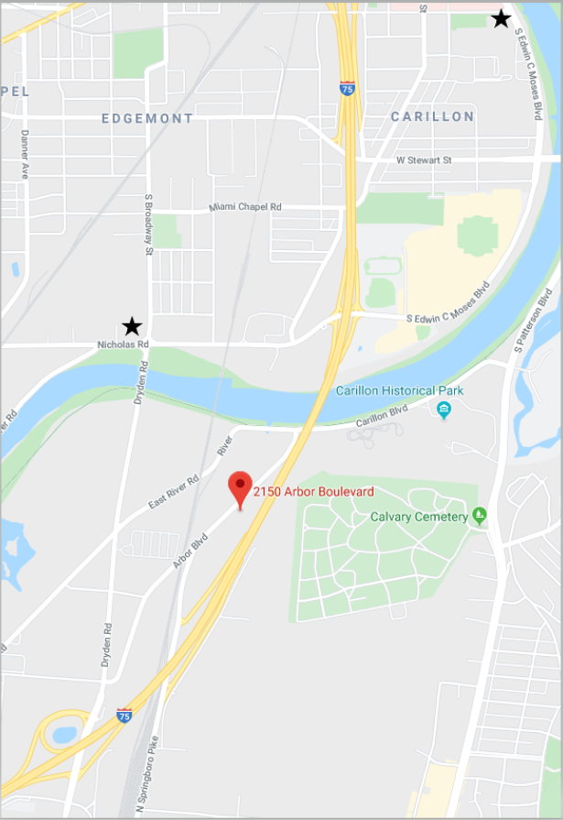
Business Meeting:
12:30 Welcome – City of Dayton
SWOWEA President – Erik Torgersen

Technical Sessions:
1:00-1:45 Dayton Parallel Interceptor Innovative Construction Methods
TBA, City of Dayton
TBA
1:45-2:30 Improvements and Lessons for Dayton’s Critical Infrastructure: Broadway Pump Stations
TBA, City of Dayton
Steven Reese PE, Hazen & Sawyer
2:30-2:45 Break & Door Prizes
Assorted Treats from Elé Bakery by RA Consultants
2:45-3:30 Maintenance and Operation a Key Factor in the Design of the City of Lima’s 13 Million Gallon CSO Storage Tank
Meredith Cariglio PE and Vito Cimio PE, Stantec

Contact hours have been applied for the Tour and Tech Sessions.
Pre-register by March XX, 2020 at www.ohiowea.org. Pre-registered fees are $25 members, $40 non-members, $5 students (w/ID), retirees $15 / Walk-ins - $35 members, $50 non-member.
Contact: Kelly Kuhbander, SWOWEA Treasurer kelly.kuhbander@strand.com or 513-861-5600.
Credit card payment is available through www.ohiowea.org only. Meeting is free for new members with paid membership application. Please honor your reservation with payment if unable to attend.

Directions to Arbor Hall, Dayton, Ohio (Moraine):
From North:
Take I-75 South to Exit 50B
Turn right off the exit onto N. Spingboro Pike
Drive north 0.2 miles to Arbor Boulevard and turn right
Arbor Hall will be 0.2 miles down on your right
2150 Arbor Boulevard

From South:
Take I-75 North to Exit 50A
Turn left off the exit onto Dyden Road
Drive north 0.3 miles to Arbor Boulevard and turn right
Arbor Hall will be 0.7 miles down on your right
2150 Arbor Boulevard

Carpooling from Arbor Hall is accommodated due to limited parking at the sites.

