SWOWEA Section Meeting
Thursday, May 16, 2019
Fairborn, OH WRC

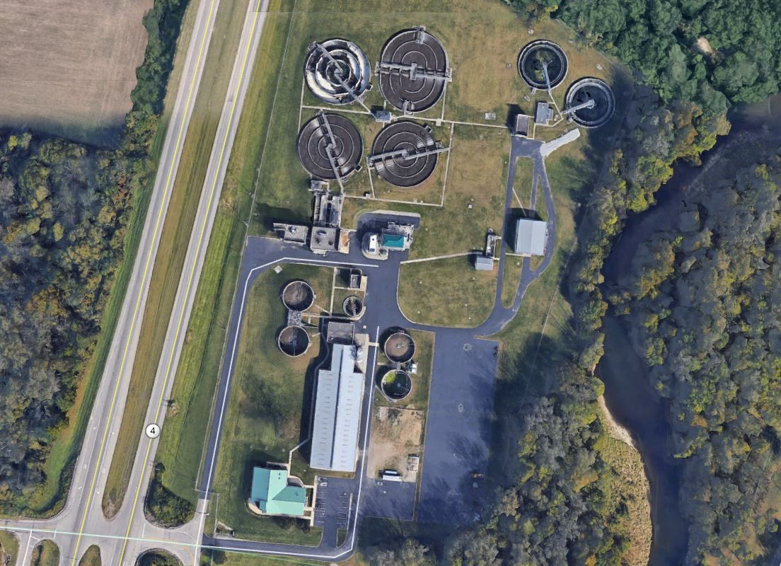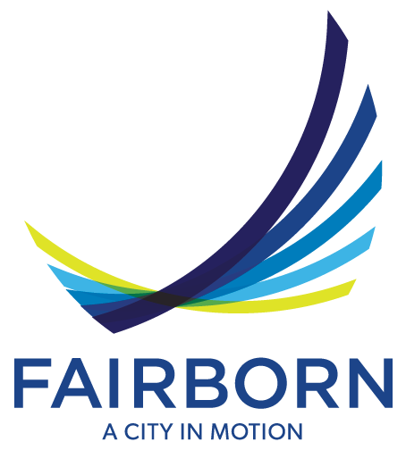

Host: City of Fairborn, Ohio

Tours: Fairborn WRC
6920 Upper Valley Rd.
Dayton, OH 45424

Coffee and Donuts
(Sponsored By Fishbeck, Thompson, Carr & Huber, Inc.)

8:30 to 11:00 Plant tour groups will leave approximately every 20 minutes from 8:30 am to 10:40 am)

OEPA-XXXXXXXXX-OM Fairborn WWTP Tour 1.0 hr

Registration: Fairborn Senior Center
11:00 to 11:30 325 N. Third St.
Fairborn, Ohio 45324
_____________________________________________
Lunch: 11:30
Provided by: Fairborn Senior Center
Pulled Pork and Chicken, Mac and Cheese, Green Beans, Cookies and Brownies for Break
Soft Drinks and Water

Business Meeting:
12:00-12:30 Welcome
Rob Anderson, City Manager
City of Fairborn, Ohio

Technical Sessions:
Sessions will begin at 12:30 PM and last until 3:30 PM.

12:30 pm – 1:15 pm – Roger Rardain, City of Fairborn – “Fairborn WRC Plant Profile”
OEPA-XXXXXXXXX-OM – 0.75 hrs

1:15 pm – 2:00 pm – Stephen Haughey, Frost Brown Todd, LLC – “OEPA’s New/Revised Minimum Staffing/Recordkeeping Rules for Operators of Record”
OEPA-XXXXXXXXX-X – 0.75 hrs

2:00 pm – 2:15 pm – Afternoon Break & Door Prizes

2:15 pm – 3:00 pm – Pooja Chari and David Vicarel, Fishbeck, Thompson, Carr & Huber – “City of Fairborn WRC Solids Dewatering Improvements”
OEPA-XXXXXXXXX-OM – 0.75 hrs

3:00 pm – 3:30 pm – TBD – Sean O’Rourke, Hazen and Sawyer - “Condition Assessment 101 for Pipes and Manholes”
OEPA-XXXXXXXXX-OM – 0.5 hrs

3:30 pm – 5:00 pm – SWOWEA Networking Event at:
TBD
Fairborn, OH
One Drink Ticket Provided with Registration

Pre-register by May 12, 2019 at www.ohiowea.org.

Pre-registration fees are $25 members, $40 non-members, $5 students (w/ID) retirees $15.

Walk-Ins are: $35 members, $50 non-members.

Contact: Kelly Kuhbander, SWOWEA Treasurer at kelly.kuhbander@strand.com or 513-861-5600.

Credit card payment is available through www.ohiowea.org only.

Meeting is free for new members with paid membership application.

Please honor your reservation with payment if unable to attend.

Directions on following page.

Directions to the Fairborn WRC:

From the North – Take I-75 Southbound toward Dayton. Take exit 61 toward I-70 East. In ~7 miles merge onto State Route OH-4 South toward Fairborn. In ~2 miles turn left (east) onto Adams Rd and arrive at Fairborn WRC in ~0.1 miles - 6920 Upper Valley Rd.

From the South – Take I-75 Northbound toward Dayton. Take exit 54B onto State Route OH-4 North toward Keowee St/Webster St/Springfield. In ~9 miles turn right onto Adams Rd and arrive at Fairborn WRC in ~0.1 miles – 6920 Upper Valley Rd.

Directions to the Fairborn Senior Center from the WRC:

From the Fairborn WRC go out Adams Rd. and turn right (north) onto State Route OH-4 North. In ~1/3 mile take the OH-235/Chambersburg Rd ramp and keep right to head East. In ~2 miles turn right on N Broad St/OH-444. In ~0.4 miles turn left on W Hebble Ave. Then take the first right onto N 3rd St. and arrive at the Fairborn Senior Center on the right at 325 N. 3rd St.

Directions to the Social at TBD

