SWOWEA Section Meeting
Wednesday, May 16, 2018
City of Eaton WWTP

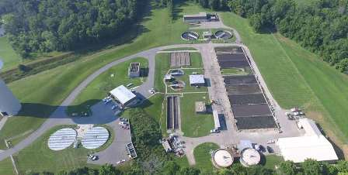

Host: City of Eaton Ohio

Tours: Eaton WWTP
901 South Barron Street (State Route 127)
Eaton, OH 45320
Coffee and Donuts (Sponsored By FTC&H)

8:30 Plant Tours Begin (Plant tour groups will leave approximately every 30 minutes from 8:30 am to 10:30 am)

Registration: The Grange
11:00 to 12:00 800 East Saint Clair Street
Eaton, Ohio 45320
_____________________________________________
Lunch: 12:00
Catering to be provided by: Adam’s Rib
Menu to follow soon.

Business Meeting:
12:30-1:00 Welcome
City of Eaton, Ohio

Technical Sessions:
Sessions will begin at 1:00 PM and last until 4:00 PM.
OEPA contact hours will be applied for each of the sessions and plant tours.
There will be one afternoon break for dessert and door prizes

Pre-register by May 9, 2018 at www.ohiowea.org.

Pre-registration fees are $25 members, $40 non-members, $5 students (w/ID) Retirees $15.

After May 9, Walk-Ins are: $35 members, $50 non-members.

Contact: Erik Torgersen, SWOWEA Treasurer at erik@delaneyandassociatesinc.com or 859-342-4944.

Credit card payment is available through www.ohiowea.org only.

Meeting is free for new members with paid membership application.

Please honor your reservation with payment if
unable to attend.

Directions:
From south: State Route 127 north to 901 South Barron Street (St. Rt. 127)
OR
From south: I-75 North to Exit 32 (OH-122), OH-122 north to left on Frizzell Ave (Frizzell Ave. dead ends at St. Rt. 127 across from plant entrance).

From north: US 35W to U.S. 127 south to 901 South Barron Street (St. Rt. 127)

