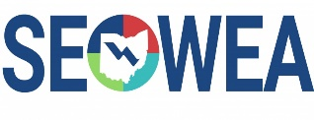
SEOWEA Ethics & Supervisor/Management Workshop, Wednesday, Oct 23 2019
(5.0 Contact Hours)

Come join us for the SEOWEA Ethics & Supervisor/Management Workshop Wednesday, Octo 23, 2019. There will be a two hour ethics course in the afternoon. The morning session will have 3 presentations on different topics that affect Supervisors and Managers. Lunch will be provided.

The City of Columbus is hosting this event at:
City of Columbus Sewerage and Drainage Division Fairwood
1250 Fairwood Ave, Columbus OH 43206

Registration:
Online Registration
SEOWWA Ethics & Supervisor/Management Workshop Please register on-line by 4 p.m. on Oct 18th, 2019.
Members: $30 Non-members: $35
First-time attendees: No Cost
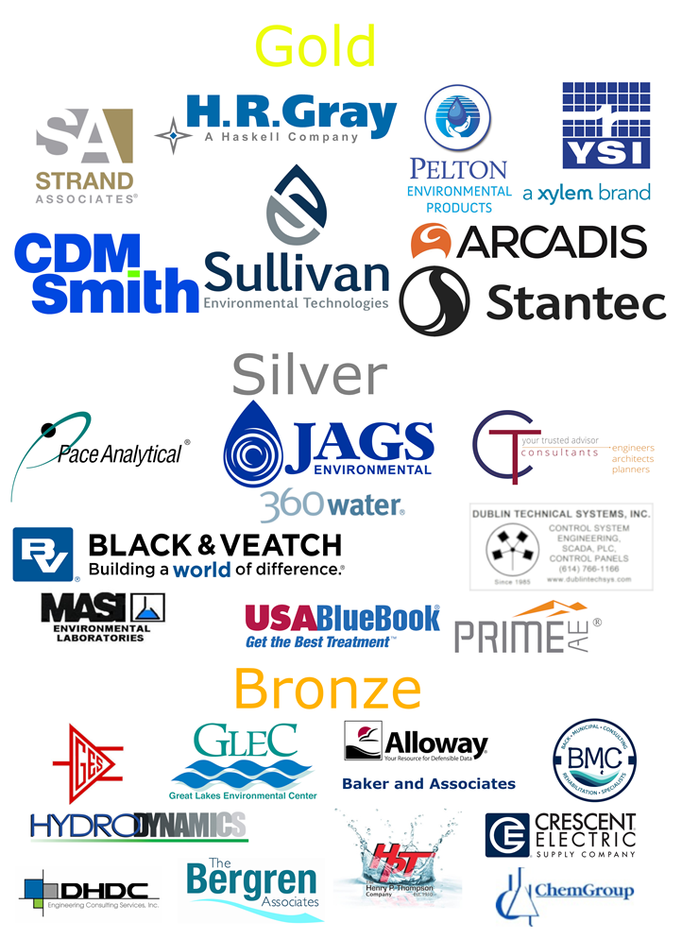
Registration at the Event
Members: $35 Non-members: $45

P.O. forms can be sent to the attention of Josh Holton at:
Southeast Section OWEA, PO Box 163093, Columbus, Ohio 43216-3093. Josh can be contacted at: Phone: 740-928-0823 or jholton@swlcws.com. If you unable to attend, please honor your reservation with a check

SEOWEA Presentation Schedule

8:30 – 9:00 a.m.: Registration City of Columbus

9:00 am – 10:00 am: Managing Transformational Growth and
Culture Change in Delaware County
(1.0 Contact hr.)
Mike Frommer P.E. & Tiffany Magg P.E.
Delaware County

10:00 am – 11:00 am: Supervisor/Manager Training
(1.0 contact hr.)
Kris Ruggles P.E.
Strand Associates

11:00 am - 12:00 pm: Achieving your leadership potential.
(1.0 contact hr.)
Amy Eberhardt and Brandon Fox
Arcadis & City of Columbus

12:00 pm - 1:00 pm: Lunch/Business Meeting

1:00 pm - 3:00 pm: The Ohio Ethics Law; It’s Everybody’s
Business.
(2.0 contact hr.)
Susan Willeke
Ohio Ethics Commission

SEOWEA is still accepting Patron Program sponsors for the 2019-2020 year. Please contact Josh Holton for additional information. Below are last year’s sponsors.

SEOWEA 2018-2019 Patron Program

