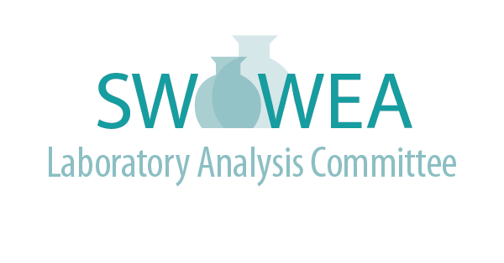

**Fall Meeting**

**October 10, 2019**

**Hosted by YSI**

A**genda**

**(5.0 Contact Hours Pending)**

* **7:45 - 8:15 Registration and Welcome**
* **8:15 - 9:15 Titration Technology & Applications – Claudia Worley, YSI**
* **9:15 - 9:30 Break**
* **9:30 - 10:30** **The Use of Freshwater Macroinvertebrates to Monitor Effluent Quality in Streams, Rhonda Mendel, EnviroScience, Inc.**
* **10:30 - 11:30 YSI Facility Tour**
* **11:30 - 12:15 Lunch Provided by YSI**
* **12:15 – 1:15** **Thirty Years of Change In The Freshwater Mussel Fauna of The Little Miami River Ecosystem, Michael Hoggarth, Otterbein University**
* **1:15 – 1:30 Break**
* **1:30 - 2:30 Bioassessment to support Clean Water Act Programs, Ed Rankin, Midwest Biodiversity Institute**

**Directions to YSI, Inc., 1700/1725 Brannum Lane, Yellow Springs, Ohio, 45387 (Look for gray “Xylem” signs)**

**Contact: Rob Smith (614-359-9209)** [**smithr@bv.com**](mailto:smithr@bv.com)

**FROM WEST or EAST**: Take Interstate 675 South and exit at East Dayton-Yellow Springs Road by Fairborn High School. Go east until Route 235. Turn right on Route 235. Take your first left onto Hyde Road. Take Hyde Road until Route 68. Turn left on Route 68 and YSI (Brannum Lane) will be on your left just before entering Yellow Springs.

**FROM SOUTH – CINCINNATI**: Take Interstate 75 to 675 North. Follow the directions above

**Registration will be limited. Register online at** [**www.ohiowea.org**](http://www.ohiowea.org)**/ and go to the ‘Event Registration’ page.**

**For additional information, contact:**

**Jim Davis, LAC Co-Chair**

**Montgomery County Environmental Lab**

**davisji@mcohio.org**

**937-781-3016**

**Lori Kyle, LAC Co-Chair**

**Greene County Sanitary Engineering**

[**lkyle@co.greene.oh.us**](mailto:lkyle@co.greene.oh.us)

**937-562-7150**

**Committee Members:**

**Dr. Rob Smith, Black and Veatch**

**Sviatlana Haubner, Cincinnati MSD**

**Craig Clements, City of Fairfield**

**Emily Mazur, City of Dayton**

**Gregg Mitchell, City of Sidney**

**Roger Rardain, City of Fairborn**