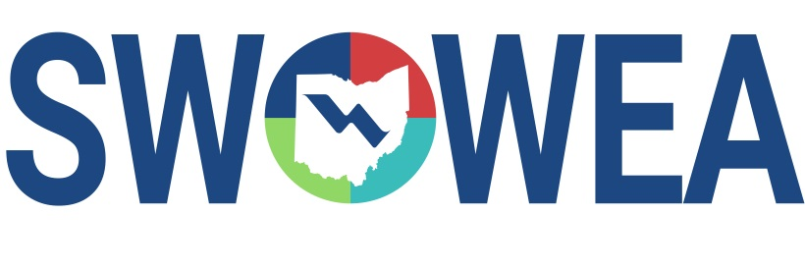
Presents the Eighteenth ANNUAL
SWOWEA PLANT OPERATIONS SEMINAR
&
SWOWEA Section Meeting
Thursday, November 14, 2019
Manor House Banquet & Conference Center
7440 Mason-Montgomery Rd.
Mason, OH 45040
Hosted by
SWOWEA PLANT OPERATIONS COMMITTEE
Presented by
SWOWEA EXECUTIVE COMMITTEE
PRESENTATIONS
Includes presentations on pumping maintenance, operation and design, high rate
Treatment systems, asset management, sludge disposal and a plant profile.
CONTACT HOURS
Up to 5.5 Contact Hours Available.
EXHIBITORS
The Seminar will include an Exhibitor area displaying various products,
Equipment and services related to plant operations and maintenance.
Pre-Register Online by 11/7/19 at www.ohiowea.org
Registrations accepted day of event on a “first come, first serve” basis, event
size may be limited, pre-registration guarantees your seat.
Pay at the door by cash or check; make checks payable to “SWOWEA”.
Questions? Please contact Alyssa Mayer at 513-469-5135 or amayer@hazenandsawyer.com

