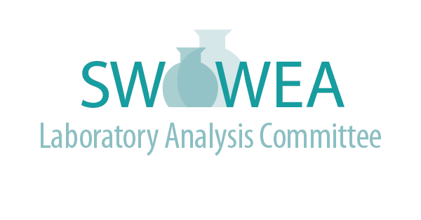

Summer Meeting
July 11th, 2019
Hosted by Greene Co. Sanitary Engineering

Agenda
(2.5 Contact Hours Pending)
- 7:45 – 8:15 Registration
- 8:15 – 8:30 Welcome, Update, and Introductions
- 8:30 – 9:30 Injury Prevention How-Tos – Gary Timmer, Suez
- 9:30 – 10:15 Specific Oxygen Uptake Rate (SOUR) What can it do for you - Dan Leavitt, City of London
- 10:15 10:30 Break – Sponsored by Greene Co. Board of County Commissioners
- 10:30 - 11:15 Auditing the Environmental Laboratory – Marcy Bolek, Alloway

Presentations will be at Greene County Social Services Media Room located at 541 Ledbetter Road, Xenia,
OH 45385.

Directions to Greene County Social Services Media Room

From Dayton: Take US 35 East to 35 ByPass around Xenia. Take the US 42 North exit. Turn right at first intersection (Ledbetter Road). Service Center is on the right.

From Cincinnati: Take I 71 North to Exit 28 (SR 48). Merge onto SR 48 North. SR 48 becomes US 42 Bypass North. Turn right on US 42. Follow US 42 through Waynesville to Xenia. After passing under the US 35 overpass, turn right at first intersection (Ledbetter Road). Service Center is on the right.

From Columbus: Take I 71 west to Exit 52A (US 68). Proceed south on US 68. In Xenia, US 68 becomes Detroit Street. Stay on Detroit Street through Xenia (do not take SR 68). Turn Right on Ledbetter Road. Service Center is on the left.

Register online at www.ohiowea.org/ and go to the “Featured Events”

For additional information, contact:

Jim Davis, LAC Co-Chair
Montgomery County Environmental Lab
davisji@mcohio.org
937-781-3016

Lori Kyle, LAC Co-Chair
Greene County Sanitary Engineering
lkyle@co.greene.oh.us
937-562-7150

Committee Members:

Dr. Rob Smith, Black and Veatch
Sviatlana Haubner, Cincinnati MSD
Craig Clements, City of Fairfield
Emily Mazur, City of Dayton
Gregg Mitchell, City of Sidney
Roger Rardain, City of Fairborn

