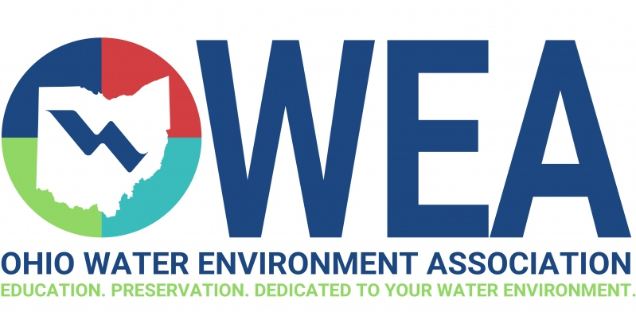

SWOWEA Plant Operations Committee Presents:
Plant Operations and Maintenance “Nearly Free” Seminar

Due to the popularity of this event, we have moved to a new, bigger location!
Date: Thursday June 7th 2018
Location: Greene County Fairgrounds
120 Fairground Rd.
Xenia, OH 45385

8:00a – 8:30 Registration
8:30a – 9:15a Smart Cover Cellular CSO Monitoring
9:15a – 10:15a Simultaneous Nitrification and Denitrification
10:15a – 10:30a Morning Break
10:30a – 11:30a Chemical Phosphorous Removal Alternatives
11:30a – 12:30p Lunch (Young’s Jersey Dairy)
12:30p – 1:15p Plant Profile
1:15p – 2:15p What to Expect During a Plant Upgrade
Part 1: Coordination with Engineers/Operators (30 Min.)
Part 2: Coordination with Engineers/Reps/Manufacturers (30 Min.)
2:15p – 2:30p Afternoon Break (Sundae Bar)
2:30p – 3:15p Sludge pumping Technologies
3:15p – 4:00p EPA Sludge Rules Update

This NEARLY FREE Seminar Offers 6.0 Contact Hours

REGISTER: online at www.ohiowea.org Questions: Bryan McNutt (937) 478-7723
COST: $15 Pre-register online by June 1, 2018 bryanm@cityofmiddleotwn.org
$20 after June1, 2018

